Task 11 : - Setting Up MySQL with Docker and Vanilla JavaScript for

Testing Database Connections

1. **Set up MySQL Using Docker**

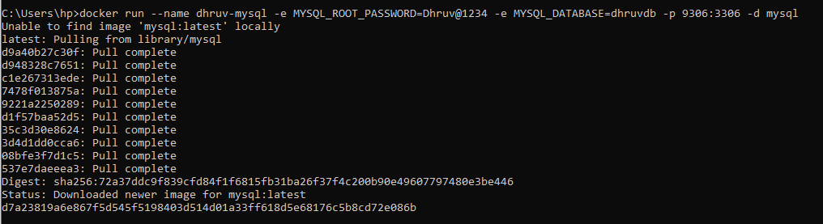

1. **Verify Container Status**



1. **Test Database Connection Using Vanilla JavaScript.**
   * **npm init -y**

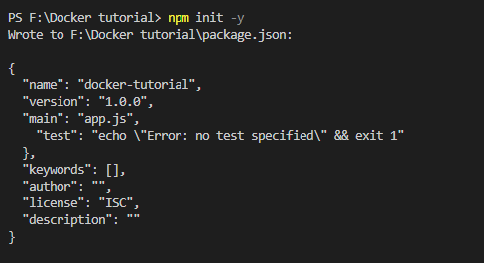

* + **npm i mysql2**

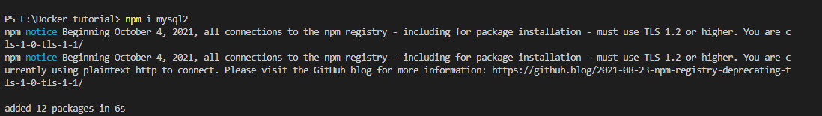

* + **Create an `index.js` file and write the code in it.**

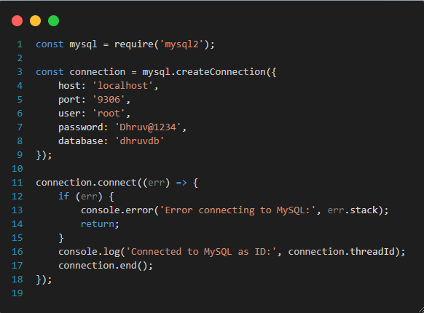

* + **node index.js**

